**TEAM PEGASUS**

**Features & Uses of the Application**

Open application

**For Mac:** Select the “TeamPeach.app” file, double click to open.

**For Windows:** Select the “TeamPeach.exe” file, double click to open.

Import file

Select “Load file” in the top left corner. Ensure that the file selected matches the type of file (Teaching, Publications, Presentations, Grants & Clinical Funding) specified by the bar in the top center.

Multiple file types can be loaded at a time; simply navigate to the proper tab (ex. “Publications”) and select “Load File…”. Your file from a previous load of a different type (ex. “Teaching”) will be preserved.

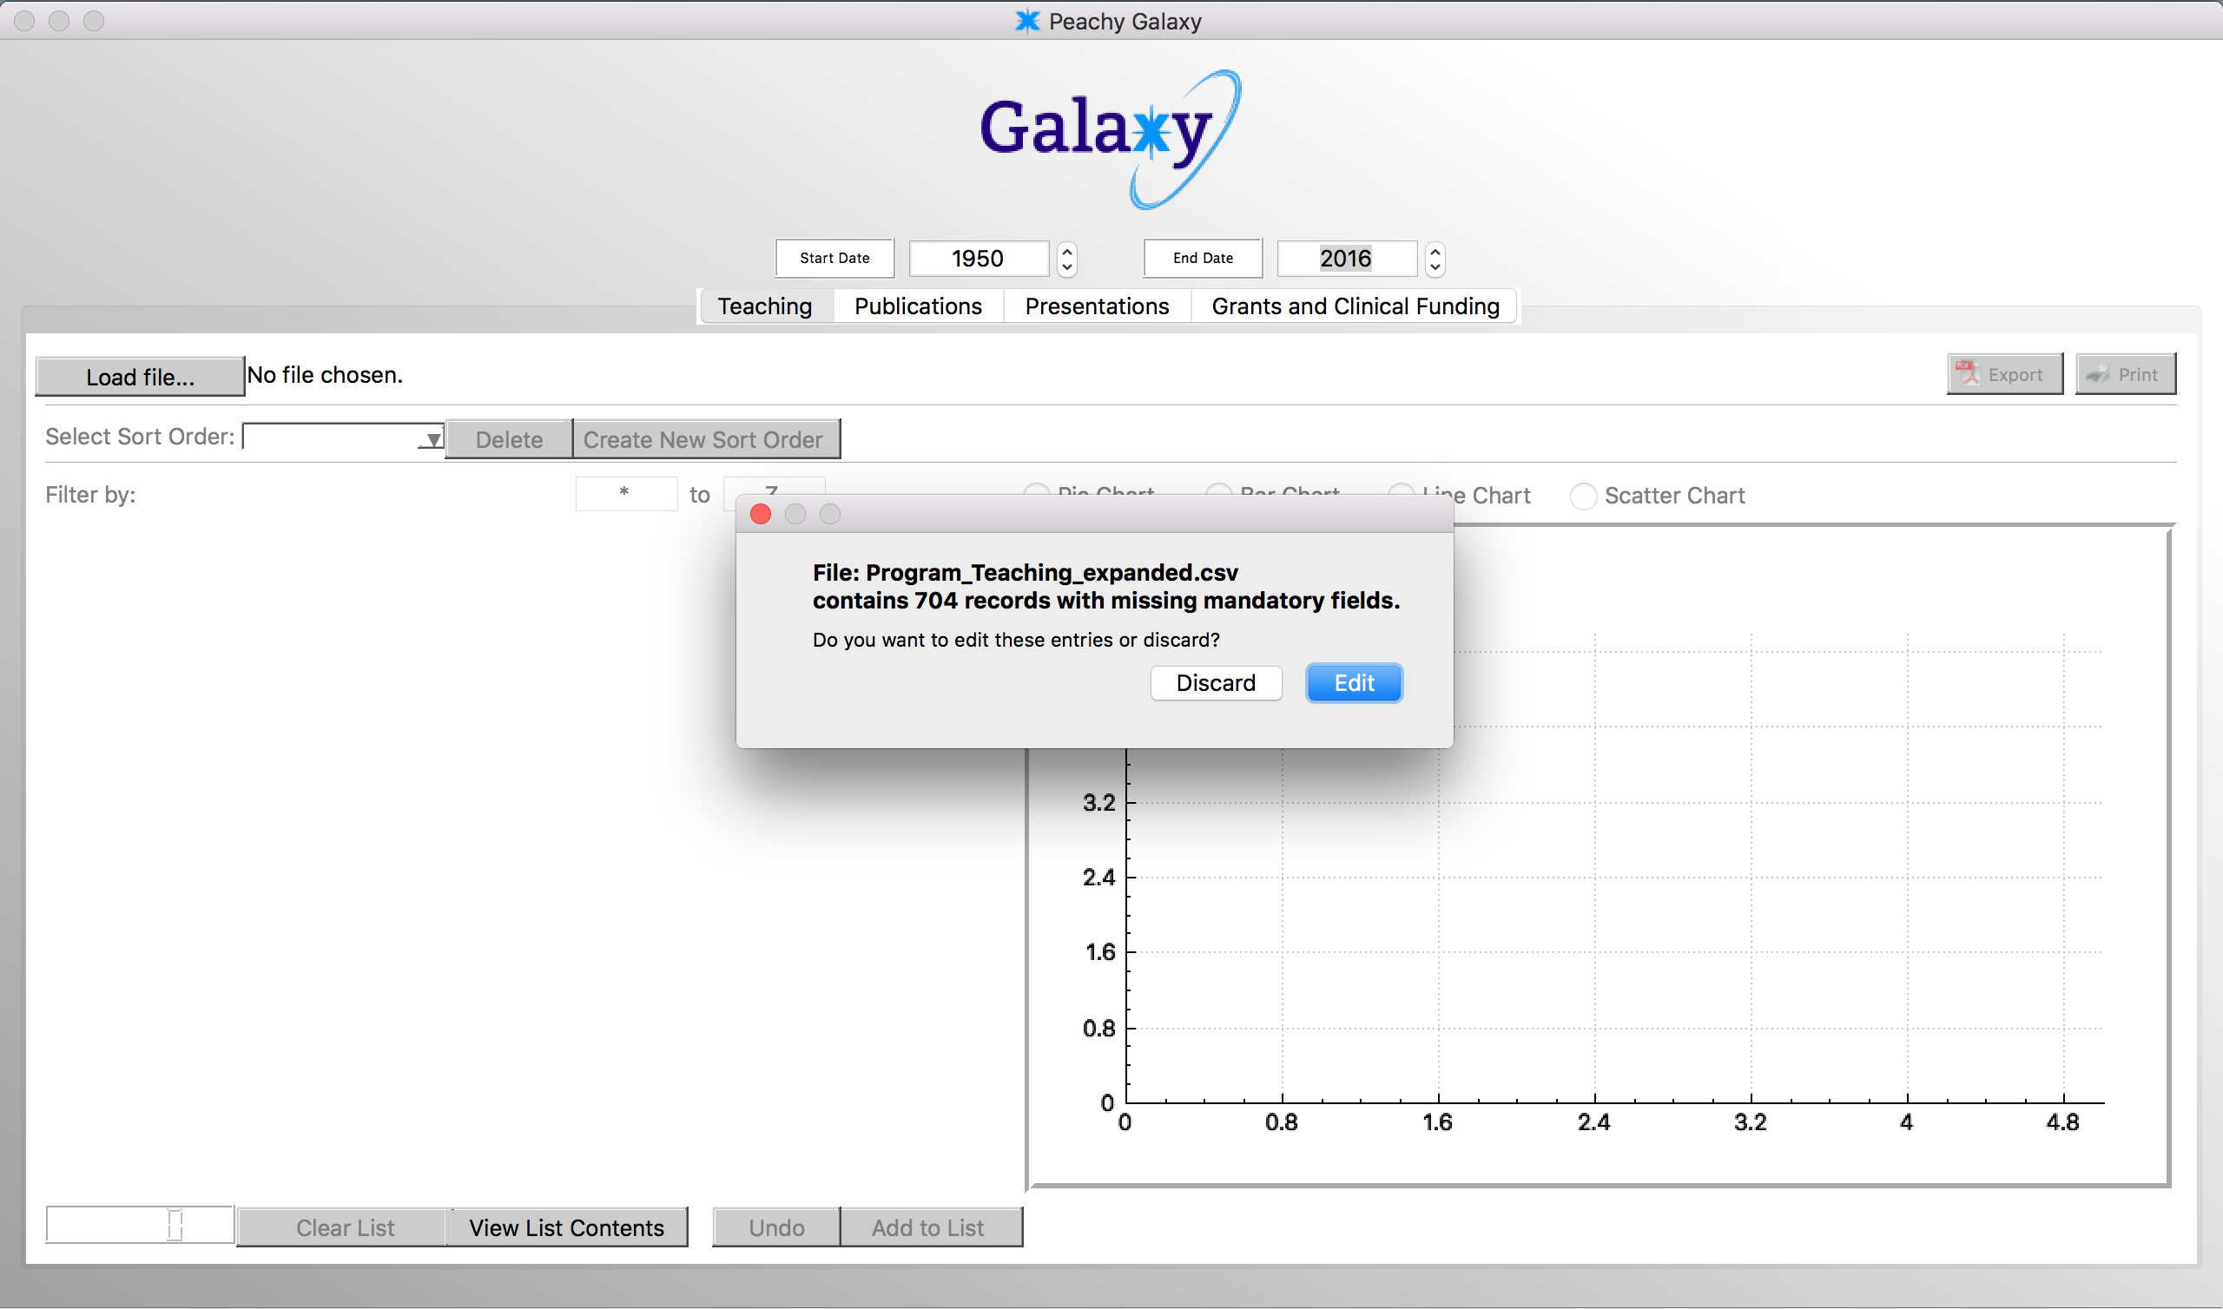

Error Navigation

If file contains missing fields, you can select “Edit” to modify any fields. To import without modification, simply select “Cancel”.

Clicking “Next Error” and “Previous Error” will take you to the next field which requires editing. The counter at the bottom left counts how many errors exist.

You can click “Save” once all errors are resolved.

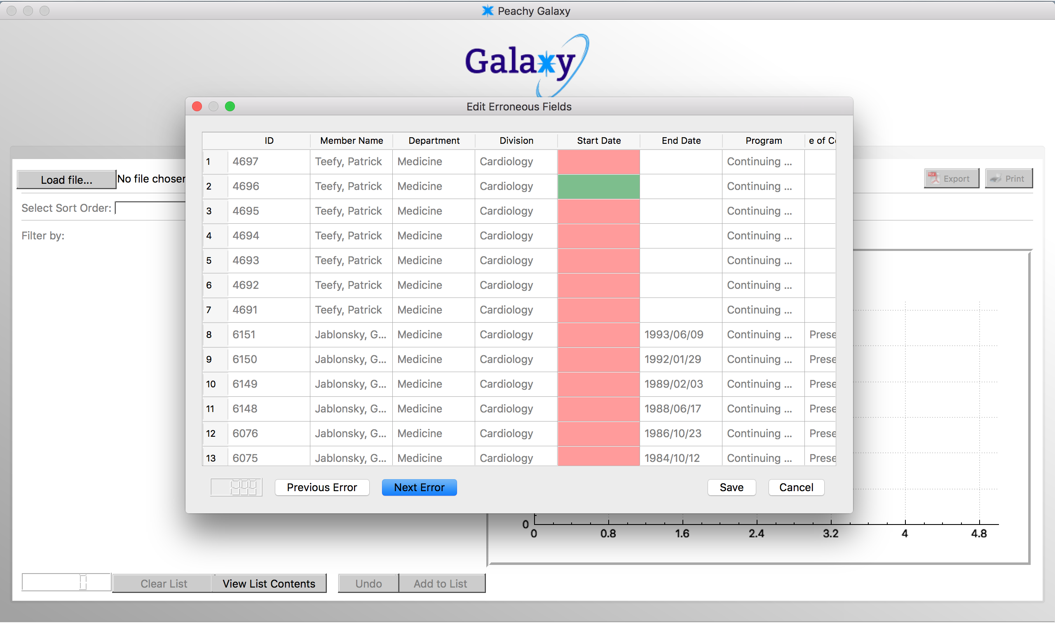

User Selected List

Users may create their own custom lists from the data fields. To do so, click on the “Member Name’ of the data field and click “Add to List”. You may “Undo” any additions to the list. The counter at the bottom left of the screen will track how many entries have been added to your list.

To view your list, click “View List Contents”. To clear the list, click “Clear List”.

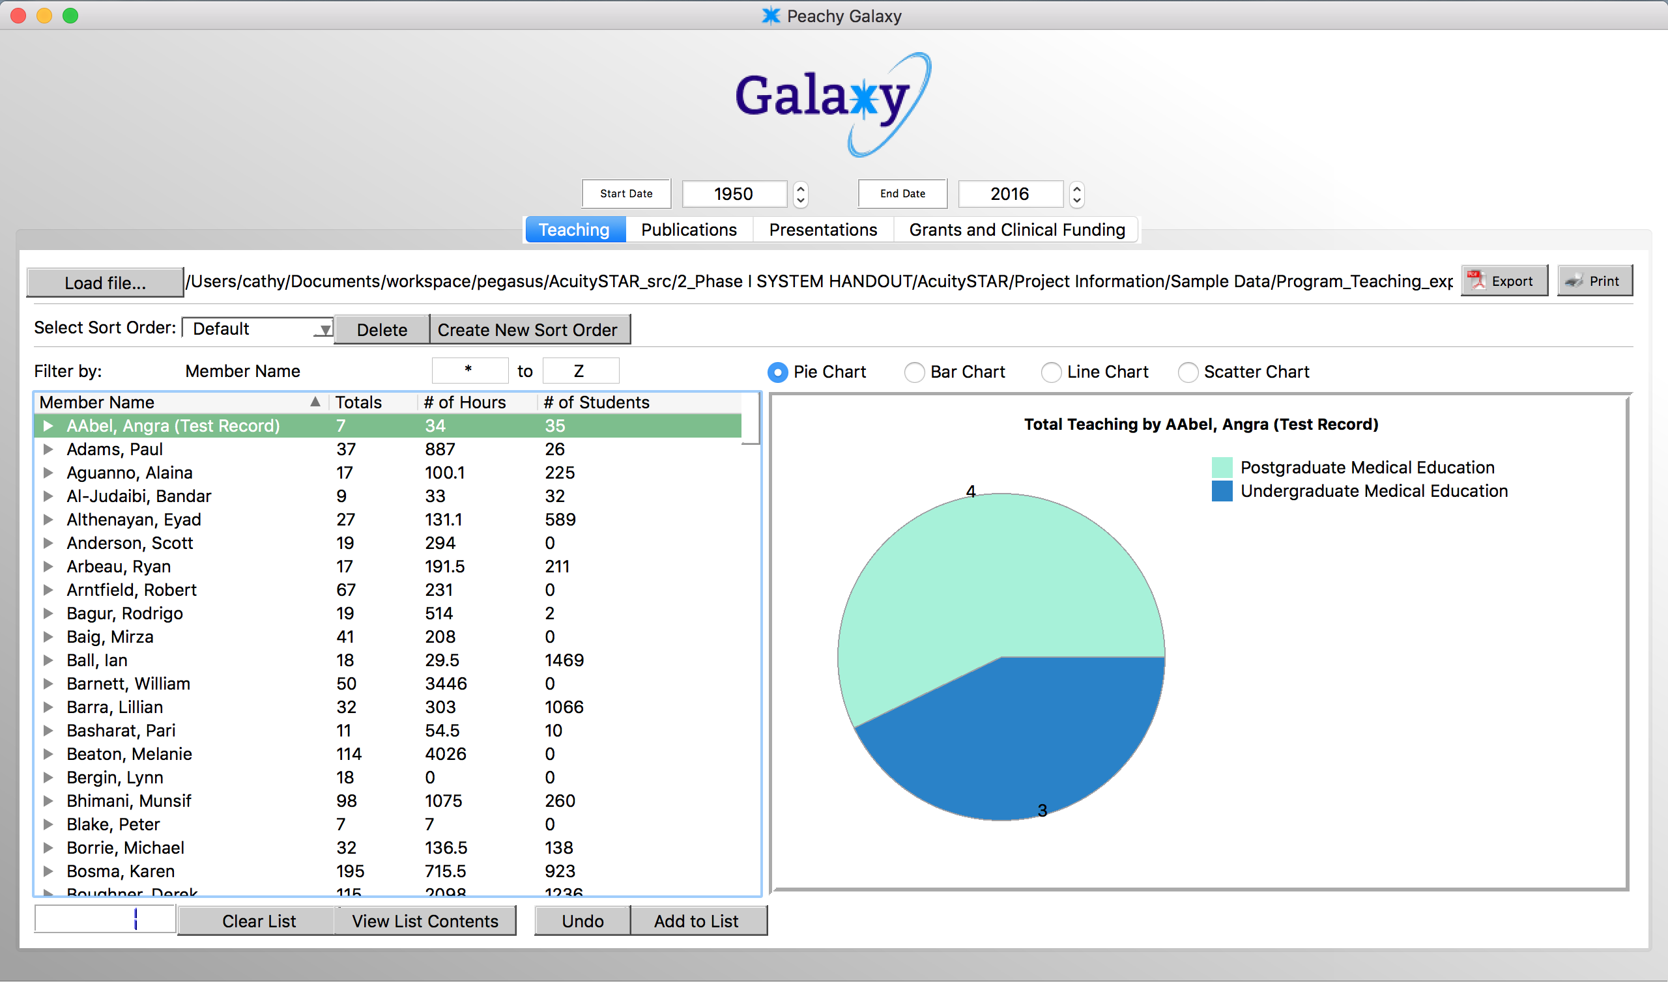

Creating a chart

Once data is loaded, simply click on the name of any individual field to generate a chart. Toggle between a Pie, Bar, Line, or Scatter chart, depending on the format you want to display the data. You can toggle the starting and ending dates at the top center of the screen.

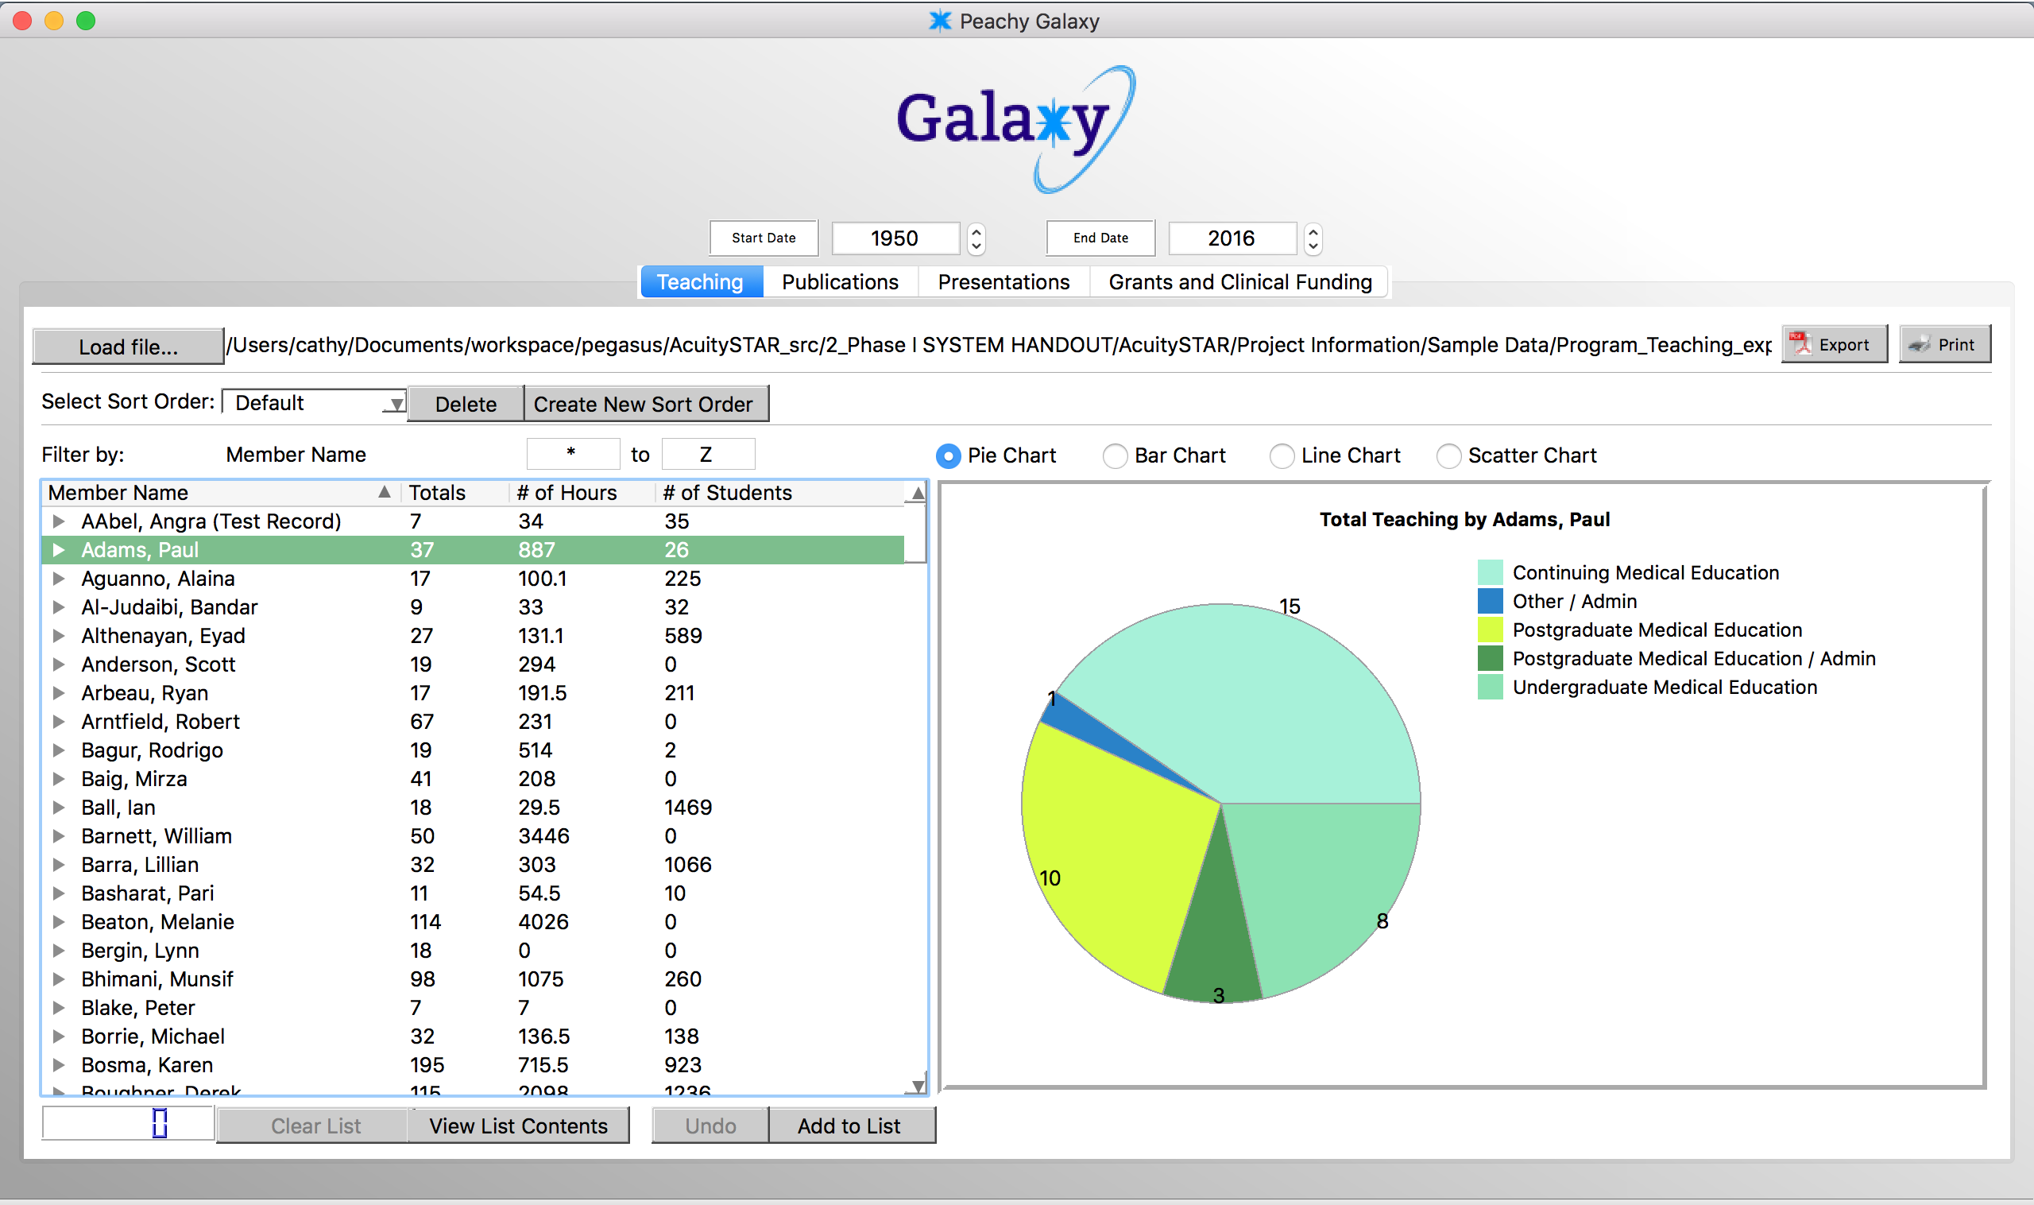

Expanding Fields

Click the arrow button to the left of data fields to expand it.

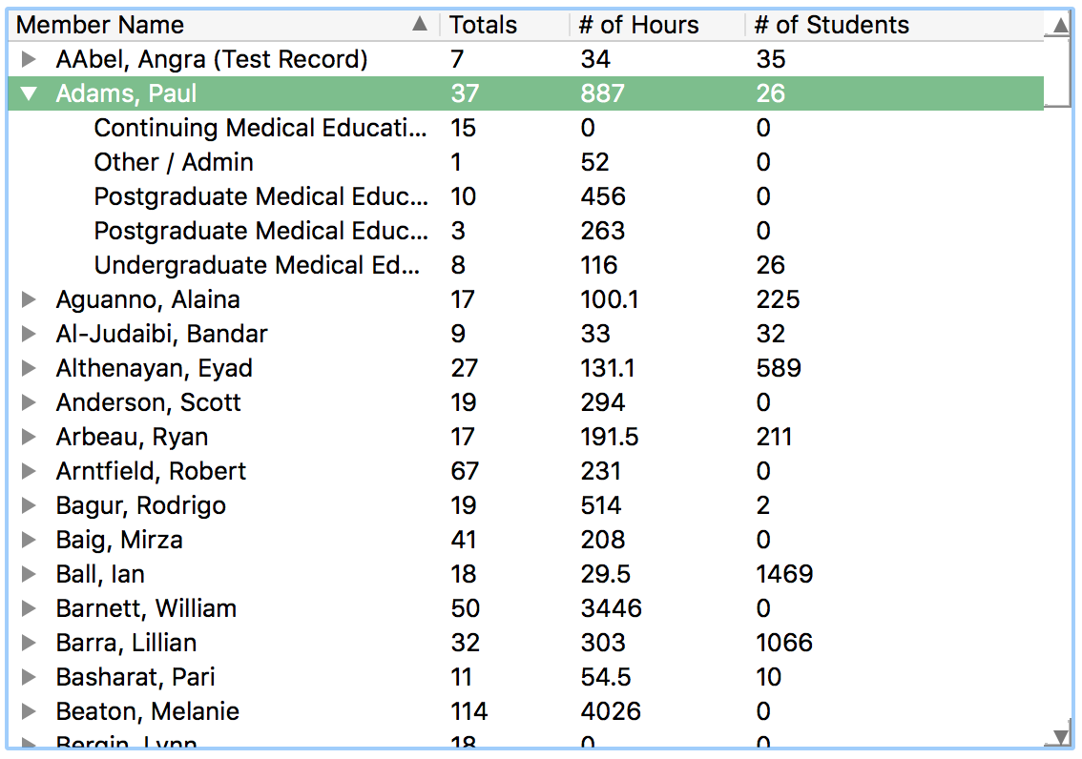

Exporting and Printing

Exporting and printing charts are easy. Simply click one of the buttons to the top right of the screen.

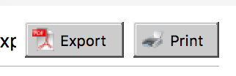

Create Custom Sort Order

Click “Create New Sort Order” and name your custom sort order. Then, select the fields that you’d like to sort by.

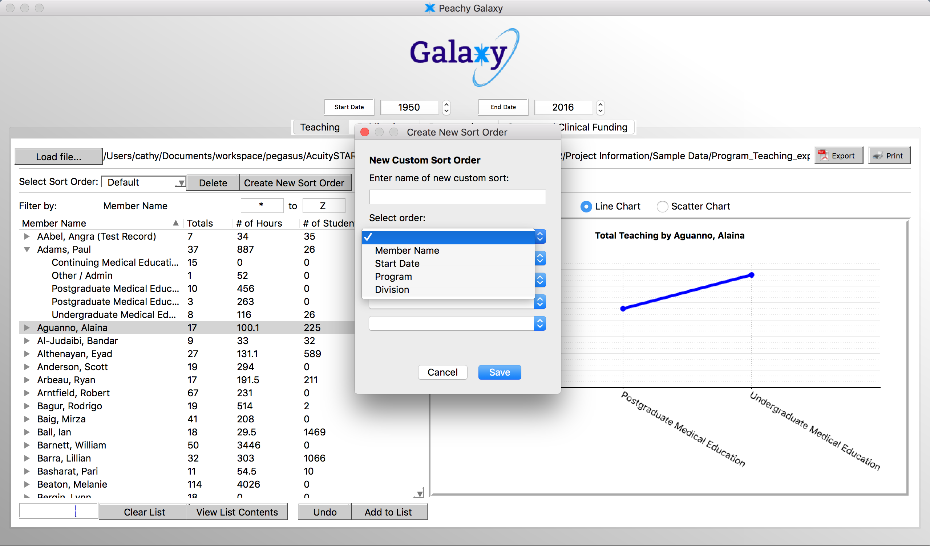

You can also change the current Sort Order you are seeing as well as delete any Sort Orders that you’ve created.